System Vision Document 3
Introduction: 3
Problem Description: 3
System Capabilities: 4
Business Benefits: 5
System Development Methodology: 5
Internal Stakeholders: 5
External Stakeholders: 6
Conclusion: 7
Work Breakdown Structure 8
Organization Chart 10
List of Requirements 12
Interview Protocols 13
Discussion and Interview Agenda 13
Setting 13
Interview/Discussion 13
Follow-Up 14
CRUD table 15
CRUD Table Technique: 15
Entities: 16
Use Cases: 18
Use Case Lists 19
Use Case Diagrams 21
Use Case Diagrams by Users: 25
Use Case Descriptions 28
Use Case Descriptions by Subsystem – Doctor Appointment Management System: 28
Subsystem: Account Management 28
Subsystem: Appointment Booking 30
Subsystem: Schedule Management 34
Entity Relationship Diagram 36
Domain Class Diagram 37
Entity and Attribute Lists 38
Attributes and Entities from the class Diagram: 38

State Machine Diagrams 41
Activity Diagrams 43
Setting Activity Diagram: 43
Future Enhancement and Additions 46
Challenges 47
Potential Challenges Impacting System Success: 47
Our Challenges During Building the Project: 48

System Vision Document

Introduction:
The Doctor Appointment Management System is a comprehensive software solution designed to streamline and enhance the process of scheduling and managing appointments between patients and healthcare providers. This system aims to revolutionize the way medical appointments are handled by leveraging cutting-edge technology to provide a seamless and efficient experience for both patients and healthcare professionals.

Problem Description:
In medical centers and clinics, managing and organizing appointments is a significant challenge that affects the quality of services provided. The administration faces issues such as overcrowding and poor scheduling, leading to difficulties in identifying available slots and overlapping appointments. Additionally, patients lack a centralized system that allows them to communicate with doctors easily or access appointment and session details. Manually recording patient and doctor data is prone to errors and consumes a lot of time for the administrative team. These problems directly impact service efficiency and patient satisfaction, requiring a digital solution to overcome these challenges.

System Capabilities:
- Data Management:
  - Collect and store information about doctors, including names, specialties, and available slots.
  - Store patient details such as names and medical conditions securely in the system.
- Appointment Scheduling:
  - Manage and schedule appointments between patients and doctors effectively.
  - Allow for the easy addition, modification, or deletion of appointments to accommodate changes.

- Information Display:
  - Display upcoming medical sessions for up to a week from the current date for better planning.
  - Provide a clear insight into scheduled appointments for both patients and healthcare providers.
- Connectivity and Accessibility:
  - Operate without an internet connection when necessary to ensure continuous service availability.
- User Interface Design:
  - Offer an easy-to-use interface for administrators, featuring a dashboard for efficient system management.
  - Provide a user-friendly interface for patients to schedule appointments and access relevant information.

Business Benefits:
- Improving communication between doctors and patients through efficient appointment scheduling.
- Ensuring accurate and effective management of appointments and schedules, reducing the likelihood of errors.
- Speeding up the process of organizing appointments and ensuring the system can handle new requests promptly.
- Enhancing the patient experience by providing an easy-to-use interface and accurate information about appointments and sessions.

System Development Methodology:
The agile development methodology is highly suitable for the development of the Doctor Appointment Management System as it emphasizes user involvement, enabling system analysts to extract relevant requirements effectively. Given that the system may undergo complexities and evolving requirements over time due to maintenance and the addition of new features, an agile approach is ideal.

Internal Stakeholders:
1- System Analyst:
- Conducts surveys and interviews with external stakeholders to grasp system requirements accurately.
- Ensures that the Doctor Appointment Management System aligns precisely with the needs of doctors, staff, and patients.
2- Project Manager:
- Responsible for overseeing and regulating project deliverables related to the appointment management system.
- Formulates and manages the project timeline to ensure timely progress and completion.
3- Human Resources:
- Manages the intricate network of relationships within the healthcare organization.
- Handles recruitment and onboarding processes, ensuring seamless integration of new staff into the system.
4- Product Development Team:
- Designs, develops, and maintains the Doctor Appointment Management System application.
- Ensures that the system meets the evolving needs of users and stays up-to-date with technological advancements.

5- Accountants:
- Responsible for managing the budgets and costs associated with developing and maintaining the Doctor Appointment Management System.
- Ensure financial stability and efficiency in the allocation of resources for the system's implementation and maintenance.

External Stakeholders:
1- Customers:
- Establish project expectations and provide frequent feedback on the Doctor Appointment Management System.
- Play a vital role in defining user requirements and ensuring that the system meets their needs effectively.
2- Investors:
- Responsible for providing the necessary funds and capital required for the development and maintenance of the Doctor Appointment Management System.
- Have the option to support the project through loans or equity investments, contributing to its financial sustainability.
3- Partner Organizations:
- Offer various resources such as staff, machinery, technology, and facilities to support the development and implementation of the Doctor Appointment Management System.

Conclusion:
The Doctor Appointment Management System represents a transformative solution aimed at revolutionizing the way medical appointments are scheduled and managed. By addressing critical issues like overcrowding, poor scheduling, and lack of centralized communication channels, this system holds the potential to significantly enhance the efficiency of healthcare services and improve patient satisfaction.
Through its robust data management capabilities, efficient appointment scheduling features, and user-friendly interfaces for both administrators and patients, the system promises to streamline the entire process, reducing errors, speeding up appointment organization, and ultimately enhancing the overall patient experience.

Work Breakdown Structure
1. Project Initialization.
1.1 Define Project Scope
  - Assemble Project Team
1.3 Develop Project Plan
1.4 Identify Stakeholders
2. Discover and understand the details of all aspects of the problem.
1- Meet with the Purchasing Department manager => 4 hours
2- Meet with several purchasing agents => 4 hours
3- Identify and define use cases => 5 hours
4- Identify and define information requirements => 1 hour
5- Develop workflows and descriptions for the use cases => 6 hours
3. Design the components of the solution to the problem.
1- Design (lay out) input screens, output screens, and reports => 10 hours
2- Design and build database (attributes, keys, indexes) => 3 hours
3- Design overall architecture => 5 hours
4- Design program details => 5 hours
4. Build the components and integrate everything into the solution.
1- Code and unit test GUI layer programs => 18 hours
2- Code and unit test Logic layer programs => 10 hours
5. Perform all system-level tests and then deploy the solution.
1- Perform system functionality tests => 4 hours
2- Perform user acceptance test => 7 hours

6. Deployment.
- 6.1 Prepare Deployment Plan
- 6.2 Set Up Production Environment
- 6.3 Deploy System
- 6.4 Conduct Post-Deployment Testing

Organization Chart

List of Requirements

Requirement ID | Requirement | Description | Type
R1 | User Registration | The system shall allow users to create an account with personal details. | Functional
R2 | Login and Authentication | Users must be able to log in securely using their credentials. | Functional
R3 | Appointment Scheduling | Users can schedule, reschedule, or cancel appointments with doctors. | Functional
R4 | Patient Profile Management | Patients can view and update their personal and medical information. | Functional
R5 | Doctor Availability Management | Doctors can set and update their availability for appointments. | Functional
R6 | Search Functionality | Users can search for doctors based on specialty, location, and availability. | Functional
R7 | Appointment Management | Doctors and admin can view, modify, or cancel appointments. | Functional
R8 | Data Security | User data must be stored securely and comply with relevant regulations. | Non-functional  (Security)
R9 | Performance Scalability | The system should handle a growing number of users without performance degradation. | Non-functional  (Performance)
R10 | User Interface Design | The system shall provide a user-friendly interface for all functionalities. | Non-functional  (Usability)
R11 | User Profile Editing | Users can update their personal information | Functional

Interview Protocols

Discussion and Interview Agenda

Setting
Objective of Interview
To thoroughly determine the functional requirements, pain points, and process improvements needed for managing and automating the doctor appointment scheduling system (eDoc) in a hospital setting.
Date, Time, and Location
April 22, 2025, at 10:00 a.m. in the hospital administration conference room.
User Participants (names and titles/positions)
Mr. Ahmed Al-Fahad, Hospital Operations Manager and several of his administrative staff
Project Team Participants
Hisham Al-Hamdi , Wadhah Ameen and Khaled Al-Haj

Interview/Discussion
• 1. How are doctor appointments currently scheduled and tracked?
• 2. What challenges do patients face when booking or rescheduling appointments?
• 3. What features would doctors find useful in managing their daily schedules?
• 4. Are there peak times or common conflicts in the scheduling process?
• 5. How are cancellations and no-shows currently handled?
• 6. What improvements are desired in notifications or reminders for appointments?

Follow-Up
Important decisions or answers to questions
Refer to the attached summary outlining the current appointment workflow and identified scheduling issues.
Open items not resolved with assignments for solution
Refer to item numbers 3 and 5 in the open items list for follow-up action planning.
Date and time of next meeting or follow-up session
April 29, 2025, at 10:00 a.m.

CRUD table

CRUD Table Technique:
Data Entity | Create | Read / Report | Update | Delete
Doctor | Create Doctor Account / Add new doctor | List all doctors /  View doctors  details | Update doctor details | Remove doctor
Patient | Create Patient Account / Register new patient | View patient details | Update patient information | Remove patient
Appointment | Schedule appointment | View appointment details | Reschedule appointment | Cancel appointment
Admin | Add new admin | List all admins | Update admin information | Remove admin
Schedule | Add (Book) a session | View scheduling  Details (session) | Update date of sessions | Remove session

Data entity/domain class | CRUD | Verified use case
Doctor | Create | Create Doctor Account
 | Read/report | List all doctors  View doctors  details
 | Update | Update doctor details
 | Delete | Remove doctor
Patient | Create | Create Patient Account Register new patient
 | Read/report | View patient details
 | Update | Update patient information
 | Delete | Remove patient
Admin | Create | Add new admin
 | Read/report | List all admins
 | Update | Update admin information
 | Delete | Remove admin

Entities:
1. Doctor
- Attributes:
  - Doctor ID
  - Name
  - Specialty
  - Contact Information
  - Availability Schedule
  - Email
  - Event / Status

2. Patient
- Attributes:
  - Patient ID
  - Name
  - Date of Birth
  - Contact Information (Telephone)
  - Medical History
  - Email
  - Event / Status
3. Appointment
- Attributes:
  - Appointment ID
  - Patient Name
  - Session Title
  - Session Date and Time
  - Appointment Time
  - Event / Status (Scheduled, Completed, Cancelled)
4. Admin
- Attributes:
  - Admin ID
  - Name
  - Contact Information

5. Schedule (Session):
- Attributes:
  - Session Title
  - Doctor
  - Schedule date and time
  - Max num booked in a day
  - Events / Status

Use Cases:
- Doctor Use Cases
  - Add Doctor: Admin can add a new doctor with details.
  - View Doctor List: Admin can view a list of all doctors.
  - Update Doctor Information: Admin can update doctor details.
  - Remove Doctor: Admin can remove a doctor from the system.
- Patient Use Cases
  - Register Patient: Admin can register a new patient.
  - View Patient Profile: Patients can view their own profile.
  - Update Patient Information: Patients can update their contact and medical information.
  - Remove Patient: Admin can remove a patient from the system.

- Appointment Use Cases
  - Schedule Appointment: Patients can schedule an appointment with a doctor.
  - View Appointments: Patients can view their scheduled appointments.
  - Reschedule Appointment: Patients can reschedule their appointments.
  - Cancel Appointment: Patients can cancel an appointment.
- Admin Use Cases
  - Add Admin: Create new admin users.
  - View Admin List: Admin can view all other admins.
  - Update Admin Information: Admin can update their own information.
  - Remove Admin: Admin can remove an admin from the system.
- Schedule (Session)
  - Schedule Appointment (Session): Patient can book an appointment with a doctor.
  - View Session Details: Patient or doctor can view details of scheduled appointments (session).
  - Update Session: Patient can modify the date or time of an existing appointment.
  - Remove Session: Patient can remove a scheduled appointment from the system.

Use Case Lists

Patient Management Subsystem
Use Case | Brief use case description | Users/actors
User Registration | Allows new patients to create an account in the system | Patient
User Login | Enables registered patients to log into their accounts securely | Patient
View Appointment History | Patients can view past and upcoming appointments | Patient

Doctor Management Subsystem
Use Case | Brief use case description | Users/actors
Doctor Registration | Allows doctors to create an account and provide their credentials and specialties | Doctor
Doctor Login | Enables registered doctors to log into their accounts securely | Doctor
View Patient History | Doctors can view patients details who have booked appointments | Doctor
View all sessions details | Doctors can view sessions details (time ect.) | Doctor
Show all appointments | Doctors can see all appointments of their patients | Doctor
Setting | Doctors can view, edit, delete account (details) | Doctor

Appointment Management Subsystem
Use Case | Brief use case description | Users/actors
View Available Appointments | Patients can view available time slots for appointments with doctors | Patient
Book Appointment  (Session) | Patients can select an available time slot and book an appointment. | Patient
Cancel Appointment | Patients can cancel their booked appointments | Patient
Search item | Patients can search for specific things in the system | Patient

Doctor Management Subsystem
Use Case | Brief use case description | Users/actors
Admin Login | Enables system administrators to log into the management system | Admin
Manage Users | Admins can add, remove, or modify patient and doctor accounts | Admin
Manage Appointments | Admins can view, modify, or cancel appointments if necessary, ensuring smooth operations | Admin
Manage Payment Processing | Admins can oversee and manage payment transactions and billing issues related to appointments  (Future) | Admin

Use Case Diagrams
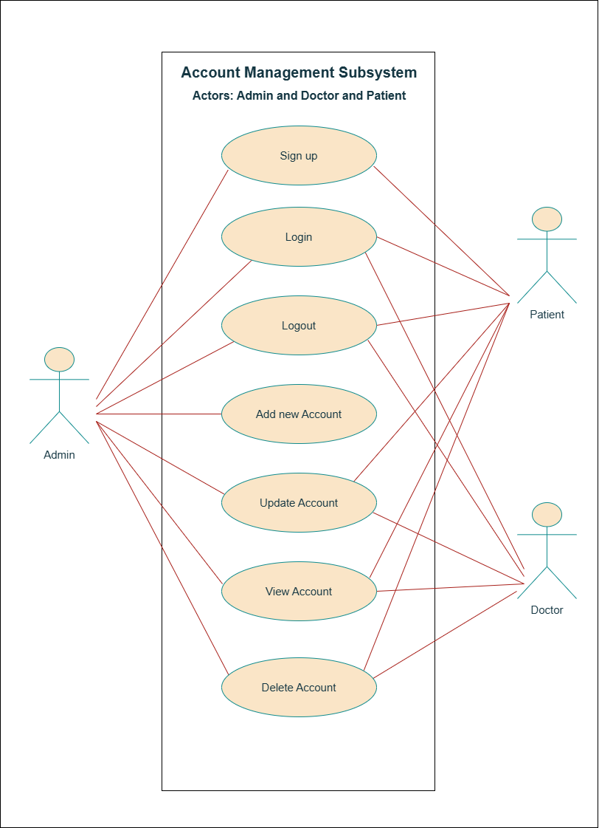
Use Case Diagrams by Subsystems:
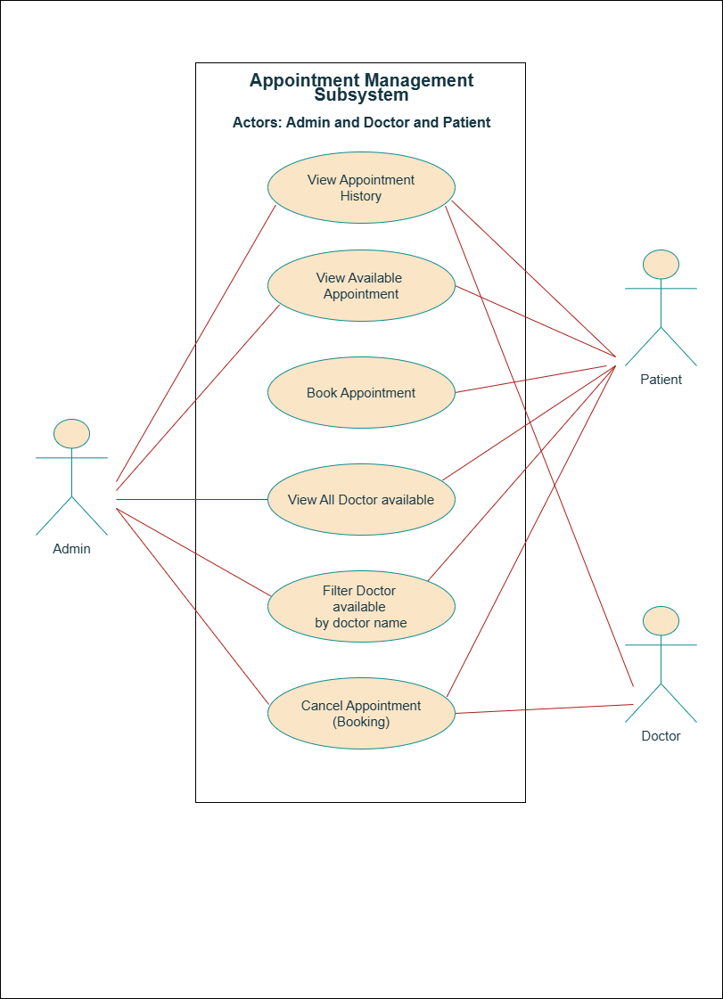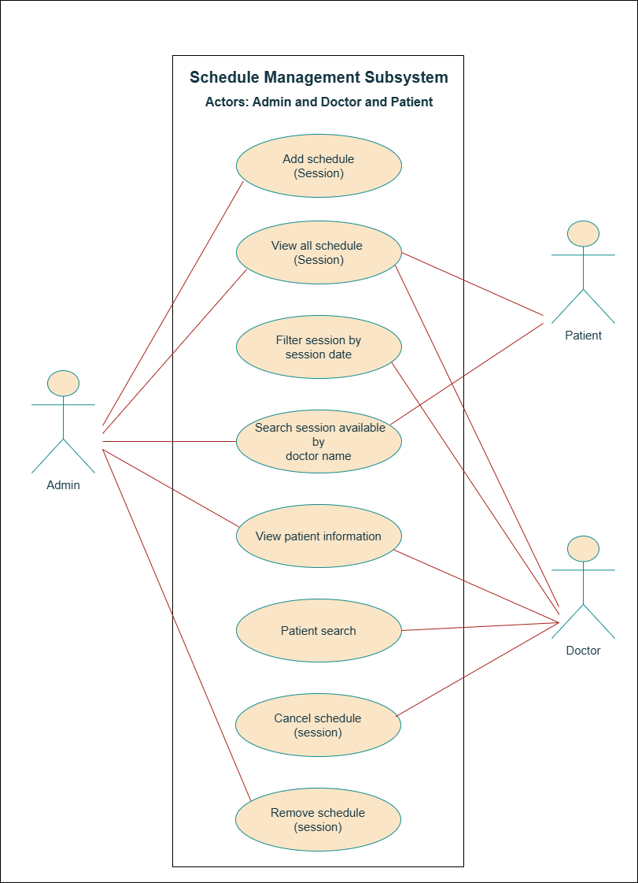

Use Case Diagrams by Users:
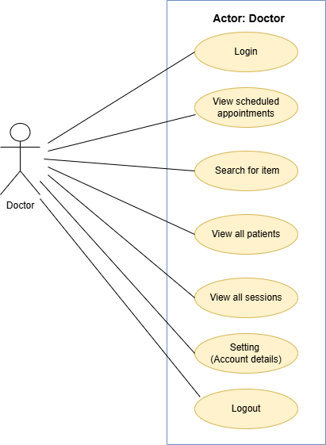
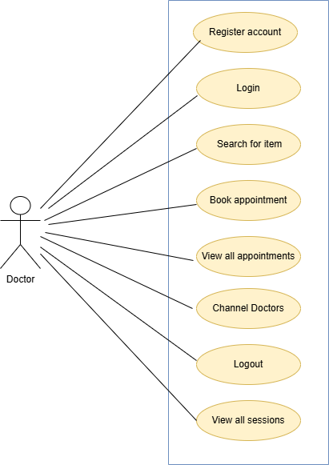

Use Case Descriptions

Use Case Descriptions by Subsystem – Doctor Appointment Management System:

Subsystem: Account Management

Use case name: Register Account
Actors: Patient
Description: This use case allows a new patient to create an account in the system by providing required information like name, email, telephone, and password.
Preconditions: The patient is not already registered.
Postconditions: The patient account is successfully created and stored in the database.
Main Flow:
1.Patient opens registration page.
2.Fills out the required form fields.
3.Submits the form.
4.System validates the input and creates the account.
5.Confirmation message is shown.
Alternate Flows:
- If email is already registered, system shows an error.
- If required fields are missing, system prompts for completion.

Use case name: Login
Actors: Admin, Doctor, Patient
Description: This use case allows users (admin, doctor, patient) to log into the system using valid credentials to access their respective dashboards.
Preconditions: The user must be registered and have valid login credentials.
Postconditions: The user is authenticated and redirected to their role-specific dashboard.
Main Flow:
1.User navigates to the login page.
2.Enter email/username and password.
3.Submits the form.
4.System verifies the credentials.
5.User is redirected to their dashboard.
Alternate Flows:
- If credentials are invalid, system displays an error message.
- If fields are empty, system prompts the user to fill them.

Use case name: Update Profile
Actors: Admin, Doctor, Patient
Description: Allows users to update their personal information.
Preconditions: User must be logged in.
Postconditions: User data is updated in the system.

Subsystem: Appointment Booking

Use case name: View All Doctor
Actors: Patient
Description: This use case allows a patient to view the complete list of doctors available in the system. Each doctor profile includes name, specialization, contact information, and available working hours. This function helps the patient make an informed choice when selecting a doctor.
Preconditions: Patient must be logged into the system with a valid session.
Postconditions: The patient sees a comprehensive list of doctors and can take further action like scheduling.
Mian Flow:
1.The patient logs in and navigates to the “Doctors” page.
2.The system queries the database for all registered doctors.
3.The system displays the list of doctors with their specialties, contact emails.
4.The patient can filter doctors by specialization or name.
5.The patient selects a doctor to view more detailed information or proceed to view available sessions.
Alternate Flows:
-If no doctors are found, the system displayed a “No doctors Available” message.
-If the system fails to retrieve data, an error message is shown with a retry option.
Business Rule:
-Only active doctors (approved by admin) are shown.

Use case name: View Scheduled Sessions
Actors: Admin, Patient, Doctor
Description: This use case enables a patient or doctor or admin to explore all upcoming scheduled sessions created by admin. Sessions include details like doctor name, doctor email, session title, session scheduled date, time. The patient can browse sessions to plan appointments.
Preconditions: Patient or doctor or admin must be logged into the system and there must be scheduled sessions added by admin.
Postconditions: The patient gets a clear view of available sessions and may proceed to book.
Main Flow:
1.Patient selects “Scheduled Sessions” from the dashboard.
2.The system fetches upcoming session data from the schedule entity.
3.All sessions are displayed, grouped by doctor or date.
4.Each session entry shows doctor name, time.
5.The patient my select filters (e.g., date rang, doctor) to narrow the list.
Alternate Flow:
-If no sessions are scheduled, the system shows “No sessions available currently”.
-If the server fails, a retry prompt appears.

Use case name: Book a Session
Actor: Patient.
Description: This use case allows a patient to finalize a booking for a selected session from the list of scheduled sessions.
Preconditions: Patient must be logged in and the selected session must not be full or expired.
Postconditions: A booking is recorded in the system.
Main Flow:
1. The patient clicks on "Book Now" next to the desired session.
2. The system checks if the session is still available and has remaining capacity.
3. If available, the system registers the booking in the database and links it to the patient's profile.
4. The booking confirmation is displayed, along with session details and cancel.
Alternate Flows:
- If the session becomes full, the system prevents booking and shows a message.
- If patient tries to book a session that overlaps with an existing booking, the system alerts the patient.
- If the patient cancels midway, no changes are saved.
Business Rule:
- Patients cannot book multiple sessions at the same time.
- A doctor’s session must be active to be bookable.

Use case name: Cancel Appointment
Actor: Patient, Admin
Description: Allows a patient and admin to cancel a previously booked appointment from their upcoming appointments list.
Preconditions:
-The patient must be logged in.
-The patient must have an active appointment scheduled in the future.
Postconditions:
-The Appointment is canceled successfully.
-The session becomes available again for booking.
Main Flow:
1. The patient navigates to "My Booking".
2. Selects booking from the upcoming list.
3. Clicks "Cancel Booking".
4. The system prompts for confirmation.
Alternate Flows:
-If the appointment is already past, the system disallows cancellation and displays a message.
-If the patient cancels too close to the session.

Subsystem: Schedule Management

Use case name: Add Schedule (Session)
Actors: Admin
Description: This use case allows the admin to define and add available working hours for doctors. These schedules become available for patients to view and book appointments.
Preconditions: Admin must be logged into the system.
Postconditions:
-A new schedule is created and associated with the doctor.
-It becomes visible to patients for booking.
Main Flow:
- Admin navigates to the “Schedules” section.
- Select “Add new Schedule (Session).
- Input session title and chooses a doctor and input number of patient/Appointment numbers and inputs schedule date, start time.
- Submits the form.
- System validates and saves the schedule linked to the selected doctor.
Alternate Flows:
- If the schedule overlaps with an existing one, system displays a conflict warning.
- If fields are missing, system requests completion.

Use case name: Delete Schedule (Session)
Actors: Admin, Doctor
Description: Allows the Admin and doctor to delete an existing schedule that is no longer valid Preconditions: Schedule exists and is not linked to any appointments.
Preconditions:
- The schedule must exist.
- It must not be linked to future appointments.
Postconditions: Schedule is successfully removed.
Main Flow:
- Admin opens the “Schedule” section or doctor opens the “My sessions”.
- Selects the schedule to delete.
- Confirms deletion request.
- System deletes the schedule from the database.
Alternate Flows:
- If the schedule has active appointments, system prevents deletion and displays an error.

Entity Relationship Diagram
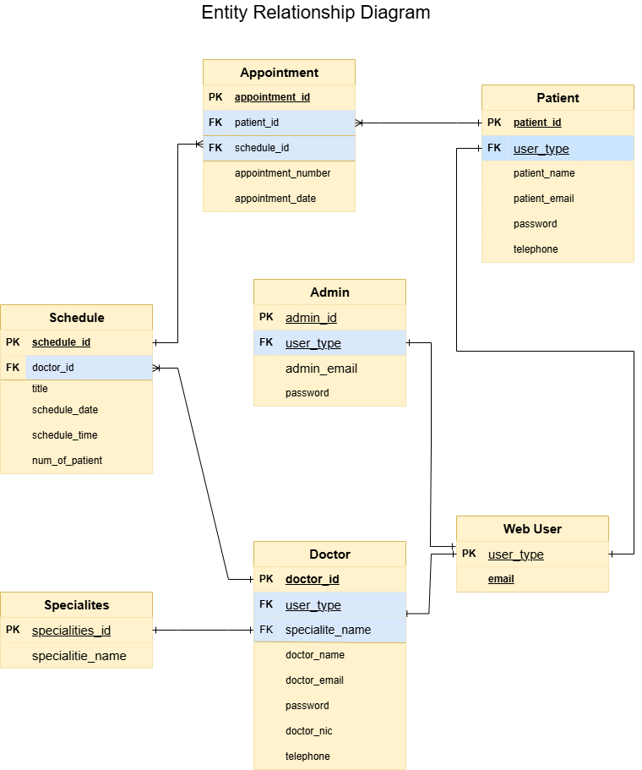

Domain Class Diagram
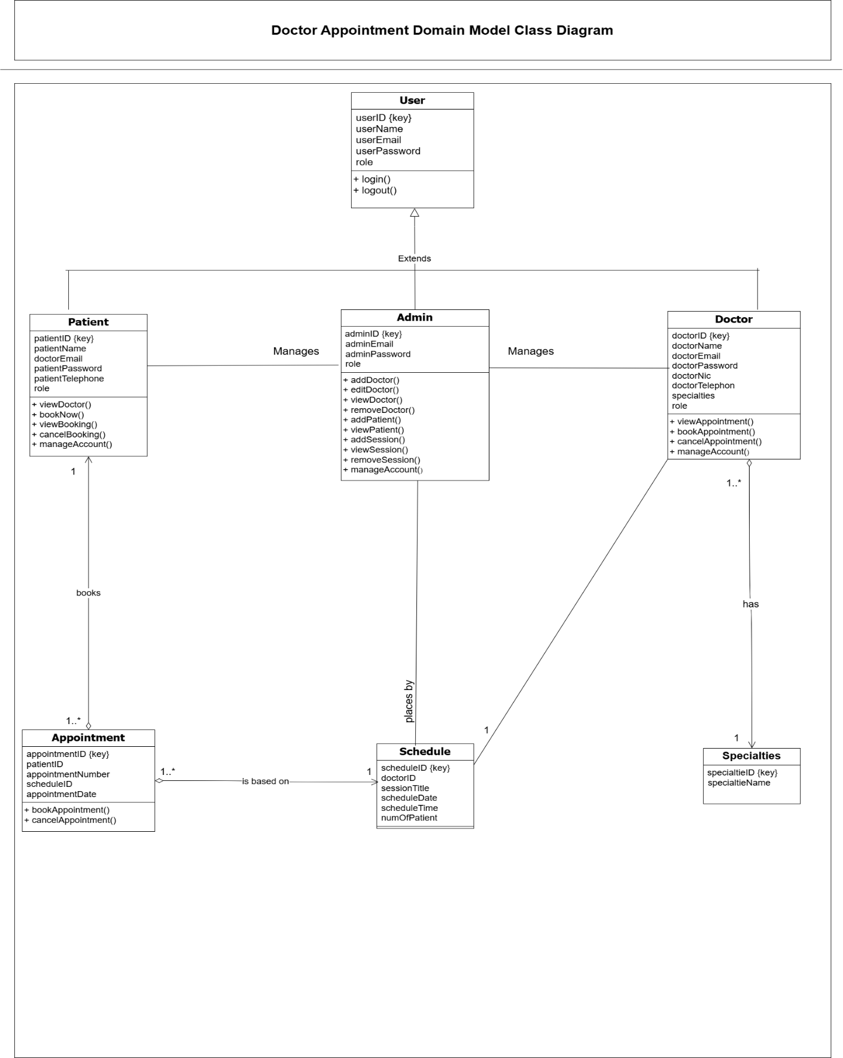

Entity and Attribute Lists

Attributes and Entities from the class Diagram:
Doctor | Attribute | Brief Description
 | doctorID (key) | A unique identifier for each doctor. (Primary Key)
 | doctorName | The full name of the doctor
 | doctorEmail | The email address of the doctor
 | doctorPassword | The password used by the doctor to access their account
 | doctorNic | Doctor's National Identification Card number or a similar unique identification
 | doctorTelephon | The doctor's telephone number
 | specialties | The doctor's area of medical specialization

Admin | Attribute | Brief Description
 | adminID (key) | A unique identifier for each administrator. (Primary Key)
 | adminEmail | The email address of the administrator
 | adminPassword | The password used by the administrator to access the system

Appointment | Attribute | Brief Description
 | appointmentID (key) | A unique identifier for each appointment. (Primary Key)
 | patientID | The unique identifier of the patient associated with the appointment. (Foreign Key referencing Patient)
 | appointmentNumber | A number assigned to the appointment
 | scheduleID | The unique identifier of the schedule associated with the appointment. (Foreign Key referencing Schedule)
 | appointmentDate | Doctor's National Identification Card number or a similar unique identification

Specialties | Attribute | Brief Description
 | specialtieID (key) | A unique identifier for each specialty. (Primary Key)
 | specialtieName | The name of the medical specialty

User | Attribute | Brief Description
 | User_email | The email address of the user
 | userRole | An enumeration (enum) indicating the user's role within the system

Patient | Attribute | Brief Description
 | patientID (key) | A unique identifier for each patient. (Primary Key)
 | patientName | The full name of the patient
 | doctorEmail | The email address of the patient's doctor
 | patientPassword | The password used by the patient to access their account
 | patientTelephone | The patient's number
Schedule | Attribute | Brief Description
 | scheduleID (key) | A unique identifier for each schedule. (Primary Key)
 | doctorID | The unique identifier of the doctor associated with the schedule. (Foreign Key referencing Doctor)
 | sessionTitle | The title or name of the session
 | scheduleDate | The date of the schedule.
 | scheduleTime | The time of the schedule

State Machine Diagrams
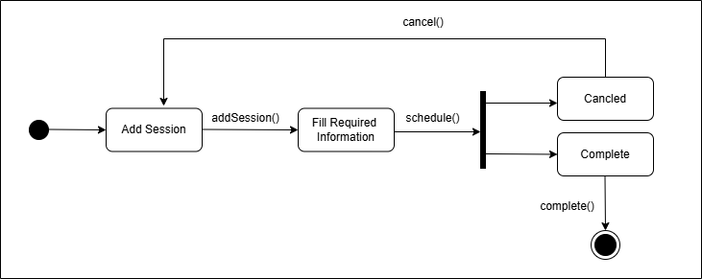
1- Add Session SMD:
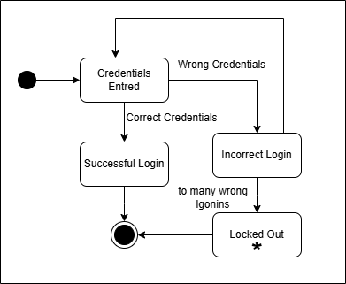
2- Login SMD:
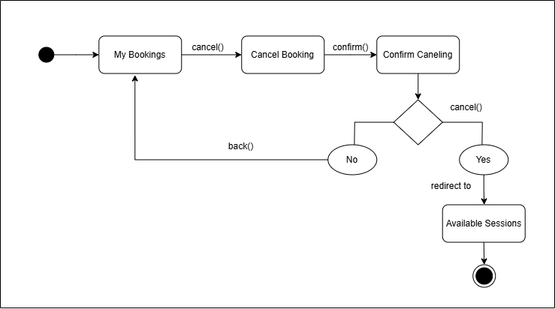
3- Cancel Booking SMD:
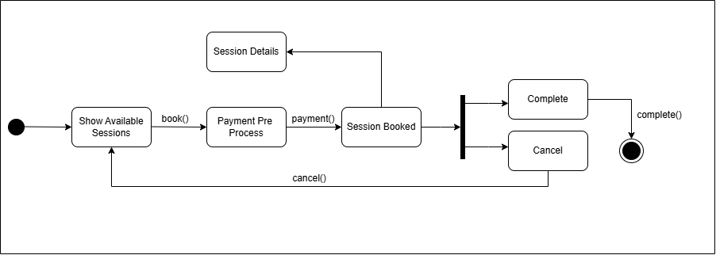
4- Book Session SMD:

Activity Diagrams

Setting Activity Diagram:
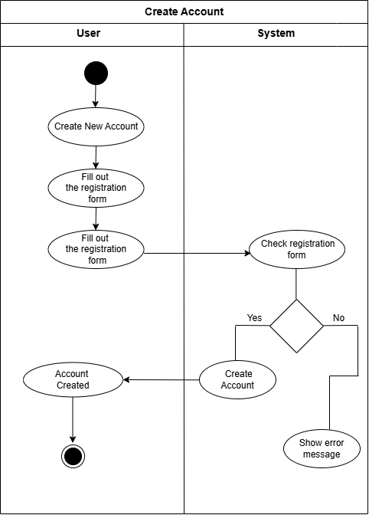
1- Create Account AD:

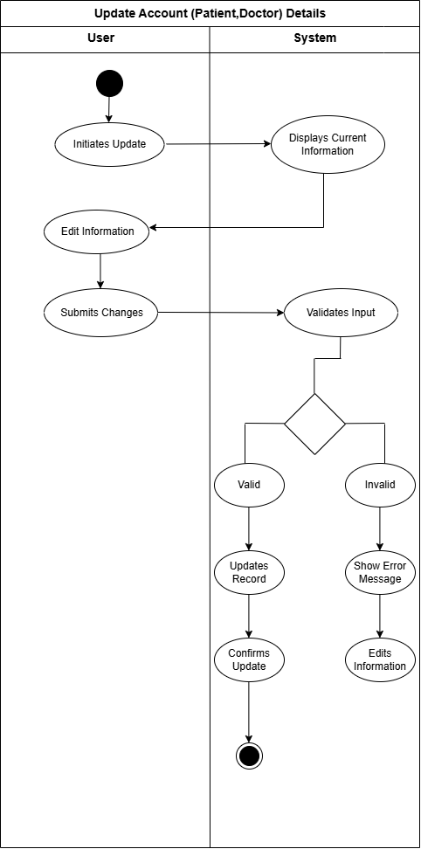
2- Update Account Details AD:

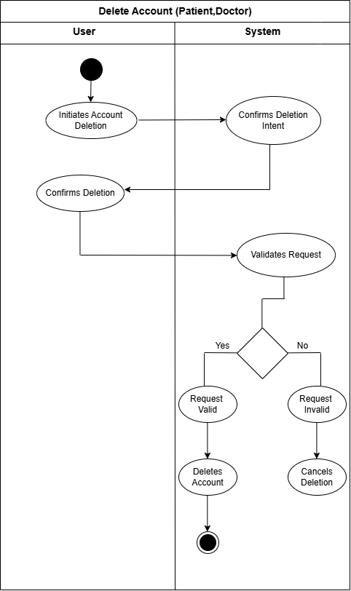
3- Delete Account AD:

Future Enhancement and Additions
Some aspects that we will add to our system to make more useful and efficient including:
- Payment Integration
  - Implement a secure payment gateway to facilitate online payments for appointments. This feature will allow patients to pay for consultations directly through the platform, improving convenience and reducing no-show rates. Payment options may include credit/debit cards, digital wallets, and insurance claims.
- Notification System
  - Develop an automated notification system to keep patients and doctors informed about appointments. Notifications can be sent via email, SMS, or in-app alerts to remind users of upcoming appointments, changes in schedule, or important updates. This feature enhances communication and helps ensure that users do not miss their appointments.
- Reports and Feedback Mechanism
  - Introduce a reporting and feedback system that allows patients to provide reviews and ratings after their appointments. This feature will enable the collection of valuable insights regarding doctor performance and patient satisfaction. Additionally, administrative reports can help track appointment trends, patient demographics, and overall system efficiency.
- Online Consultation Services
  - Expand the platform to include online consultation services, enabling patients to have virtual appointments with doctors. This feature will cater to patients who prefer remote consultations due to convenience or health concerns. It may include video conferencing capabilities, ensuring that patients receive high-quality care from the comfort of their homes.

Challenges

Potential Challenges Impacting System Success:
1. User Resistance to Change
Users often resist new systems due to fear of the unknown or discomfort with new processes. This resistance can lead to low adoption rates, undermining the system’s effectiveness. To mitigate this, effective change management strategies, including user training and involvement in the design process, should be implemented.
2. Inadequate Requirements Gathering
Failure to accurately gather and document requirements can lead to a system that does not meet user needs. This can stem from a lack of communication between stakeholders and developers. To overcome this, continuous engagement with users and iterative feedback loops should be established to refine requirements.
3. Technical Limitations
The technologies chosen for the system may not support all required features or may have limitations that impact performance. It is essential to conduct thorough research and feasibility studies on the technologies before making decisions, ensuring they align with project requirements.
4. Integration Issues
Integrating the new system with existing systems can pose significant challenges, particularly if those systems are outdated or lack proper documentation. A well-defined integration strategy, including testing and phased rollouts, can help address these concerns.
5. Security Risks
As systems become more interconnected, they may become more vulnerable to security breaches. Ensuring robust security measures, including encryption and regular security audits, is vital to protect sensitive data and maintain user trust.

Our Challenges During Building the Project:
1. Time Management
Balancing project work with other commitments (like classes, work, or personal life) can be challenging and waste from us sometimes in both sides.
2. Technical Skills Gap
We found that certain technical skills required for the project are beyond our proficiency since we are still beginners. This may have created frustration and slow down on our progress, but we overcome this, by dedicating time to learning these skills through online courses and tutorials.
3. Understanding Requirements
Interpreting and translating user requirements into functional specifications was really complex which sometimes led us to rework some aspects due to misunderstanding.
4. Problem-Solving Challenges
We encountered unexpected issues and bugs during developing our system.
5. Collaboration Difficulties
When working on a project with a team, I've found that coordinating with others can be quite challenging. We often have differing schedules, work styles, and sometimes even communication barriers. To tackle these issues, I’ve learned the importance of establishing clear roles for each team member. Regular check-ins help keep everyone aligned and accountable. But still working with teammates is a quite good concept.
6. Scope Creep
As the project progresses, I’ve noticed that there could be a tendency for additional features or changes to be requested. This could lead to scope creep, which can complicate things. To tackle this, I plan to stay focused on the original project goals and manage any changes through a formal process. This approach helped me keep the project on track and ensure that we deliver what we initially set out to achieve.

